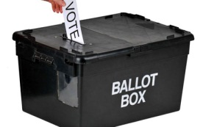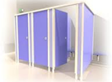

**SCEMATIC I (b)**: SET-UP FOR VOTING IN STAND-ALONE POLIING UNIT

**APO III Queuing**

**Queue**

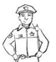

**Security Personnel**

**APO II Ballot Paper Issuance & Inking**



**Security Personnel**

**APO I (Overseer)**

**PRESIDING OFFICER**

**Voting Cubicles**

**Observers**

**Party Agents**

**Entry/Exit**