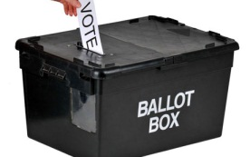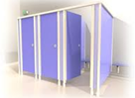

**SCHEMATIC II** (**b**): SET-UP FOR VOTING IN A VOTING POINT

**Queue**

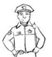

**Security Personnel**

**APO II Ballot Paper Issuance & Inking**



**Security Personnel**

**APO III Queuing**

**APO I (Overseer)**

**APO (VP)**

**Voting Cubicles**

**Observers**

**Party Agents**

**Entry/Exit**